Integrate TGE in project streams
The way we work with TGE in the group projects, is that we integrate the TGE stream into the group project streams.
The main reason for this is that it makes it possible for each group to integrate fixes and new things that are added to the mainline TGE stream. It carries over revision history and similar, which makes it so that groups can integrate again to “update” if we do bug-fixes and similar.

How do you do the integration?
Good news is that it is pretty much the same if you do it the first time to get TGE at all, or if you do it down the line to integrate a bugfix.

First of all
Once the group streams for a project has been created you are assigned to your streams by one of the educators. Typically the streams are structured as this: //STHLM25_Projekt/ProjektX/GruppY/STO25-PX-GY
(OBS! This exact path might differ at different locations, but there should be a stream fore each project and group)
So if I have a look at streams in P4V and now I filtered so I can only see streams with a name starting in “STO25-P3”, and we will make use of the stream STO25-P3-GQ
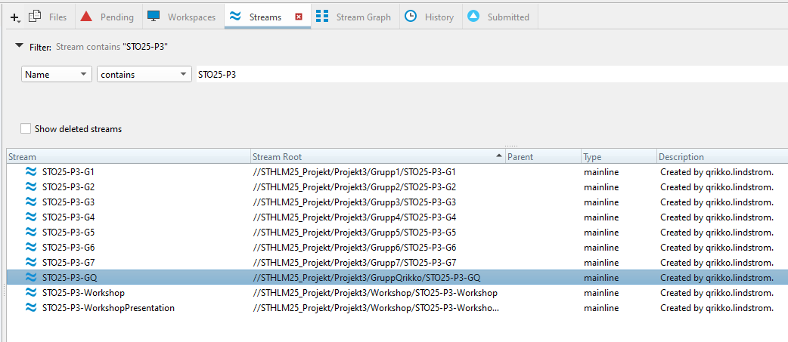
Here I can right click and select Work in this stream
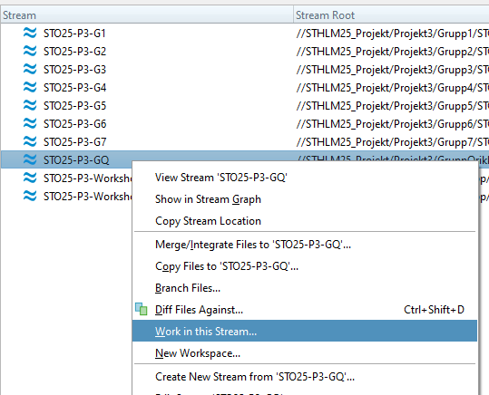
It will ask me to create a workspace which is my local connection to the stream where I do my work before submitting it to the server.
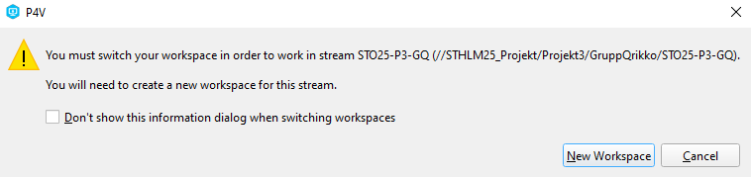
I then select a reasonable folder on my own computer, where I want to have the local files which I work with.
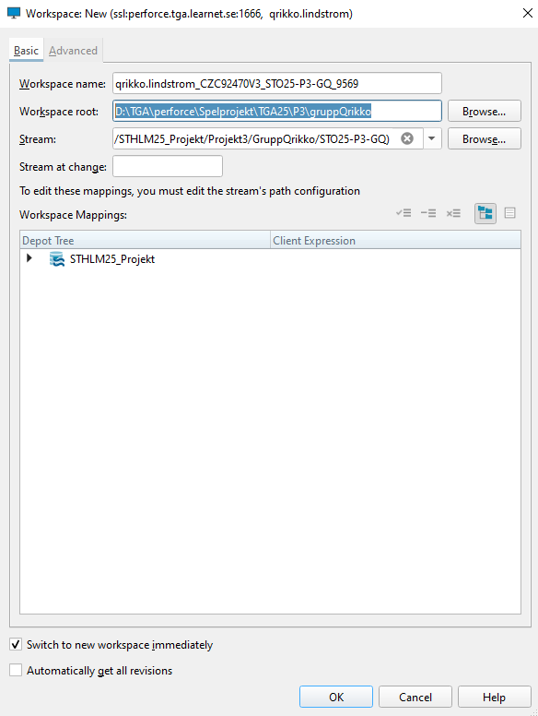
In P4V it will switch to the workspace and I should have an empty project at this point. It might ask if you want to populate the stream since it is empty, if so, Cancel it and let it be empty. (when it is empty you will not see it in the Depot-view, but you should see your workspace if you make sure the workspace tab is selected.
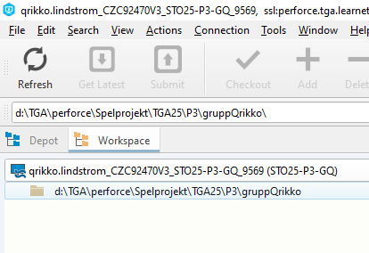

Integrate TGE to your stream using the workspace
So next up is actually to do the integration. To do this you can right-click the folder in the picture above and select Merge/Integrate Files…
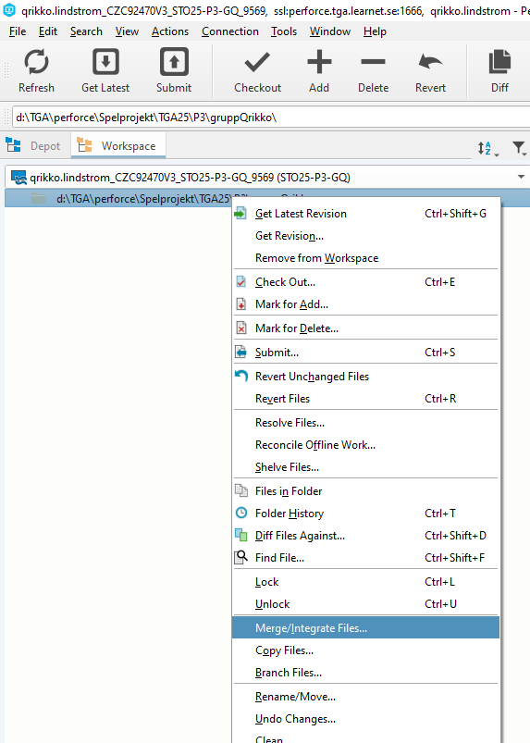
This will bring up a window asking how to do the integration. In this window you will want to make sure that Specify source and target files is selected in the top drop-down.
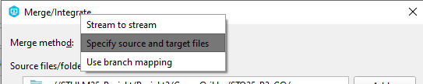
If you (like me in this example) have your stream set in the Source files/folders: part make sure to select that line (click on it) and click Remove to the right.
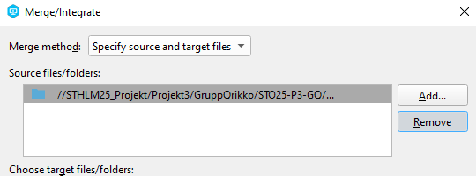
We don’t want to integrate to our project form our project, we want to integrate from TGE, So Click the Add… button in the same section. This will bring up a list of depots (probably you will find it a fair bit shorter than mine, since I see everything). Locate the TGE depo, and within it you should find TGE (tge) as seen in the picture, that is the Source you want to select.
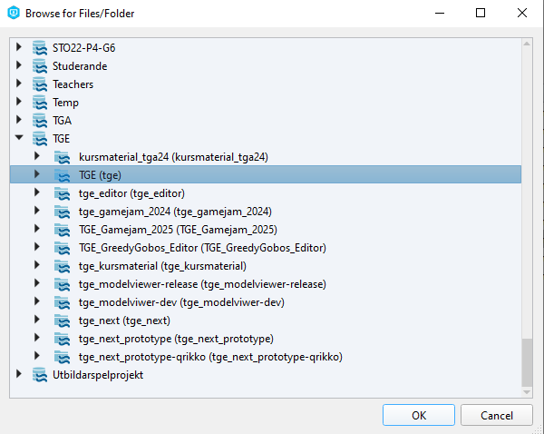
Select it and click the OK button.
If you want to make sure that everything is correct you can hit the preview button and you should see something like this
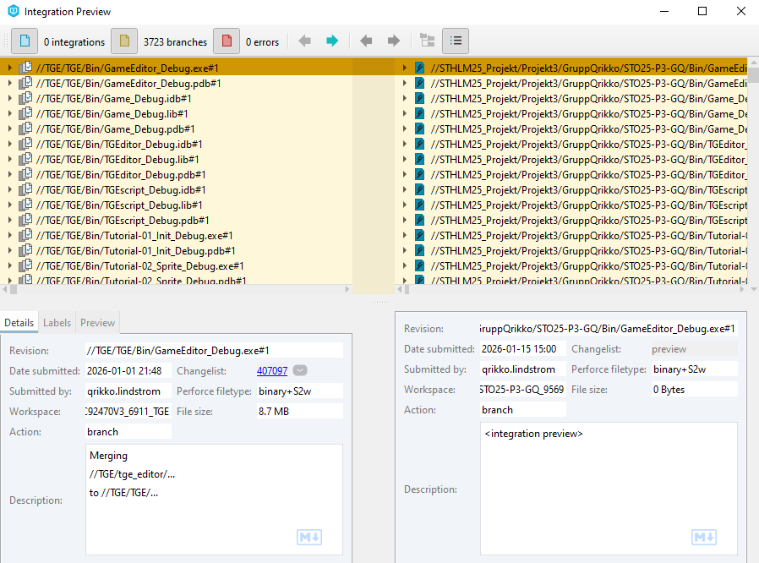
If not, and just in general, make sure that your Target is selected to the correct target, which should be correct if you selected merge/integrate from the workspace as shown in this document:
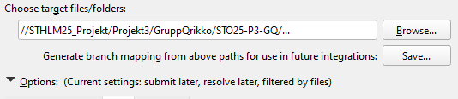
If everything is in order you click the Merge button in the bottom of the window
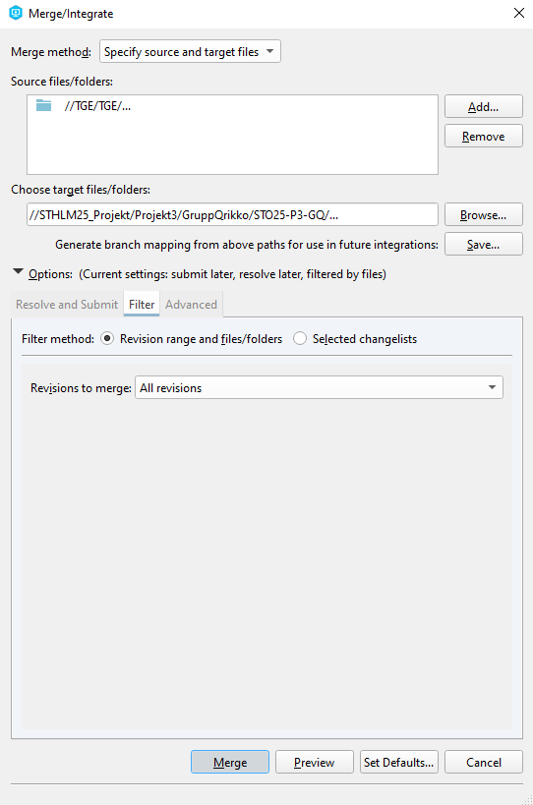
It will work for a bit, and what it is doing is that it is calculating all the changes integrating all the files of TGE into your stream and putting it together in a changelist containing the merge. Once it is done you can go to the changelist tab in P4V and you should have a changelist containing the merge.
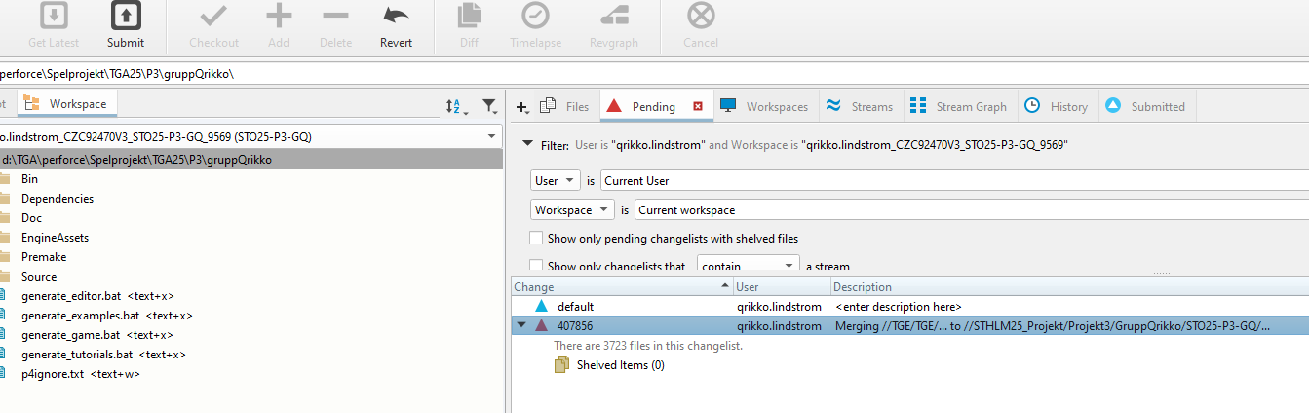
So all that we need to do now is to submit the changelist. We do this by right clicking the changelist and selecting Submit.
Once it is submitted your team members should see the group stream under Depots and if they create their own workspaces and click Get Latest the integrated TGE should be downloaded to their workspace.

